CSI223 LAB 7
Name: Keletso Joy Ditlhotlhole
Student ID: 202002023

- I created the sub directory csii223_lab7
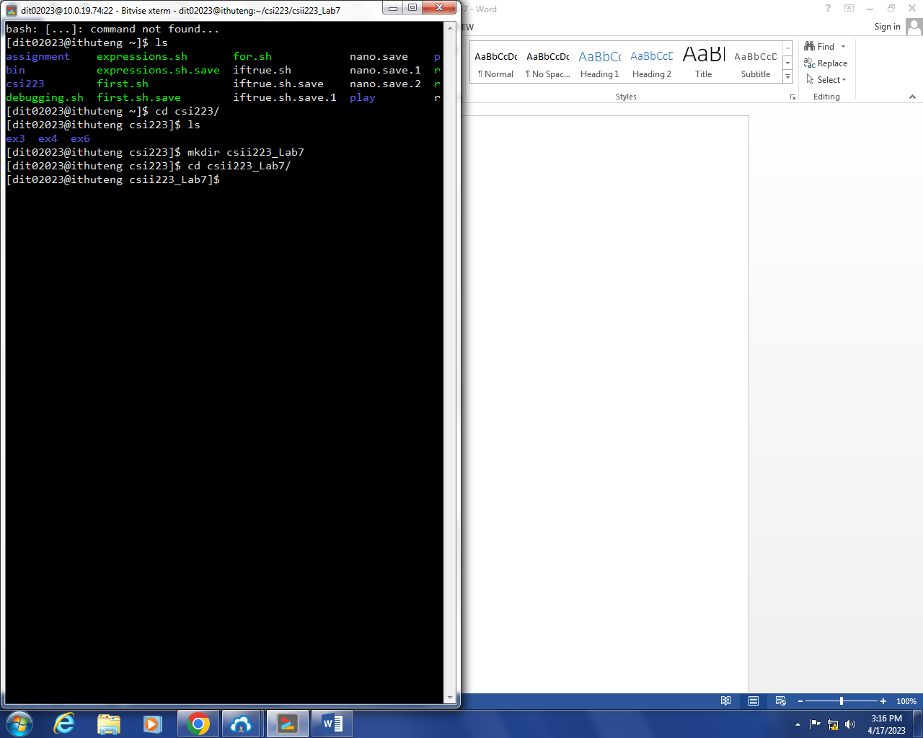

- i. length of $str- I used length() function to find the length.
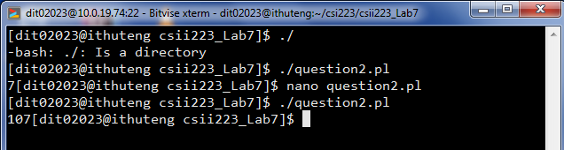
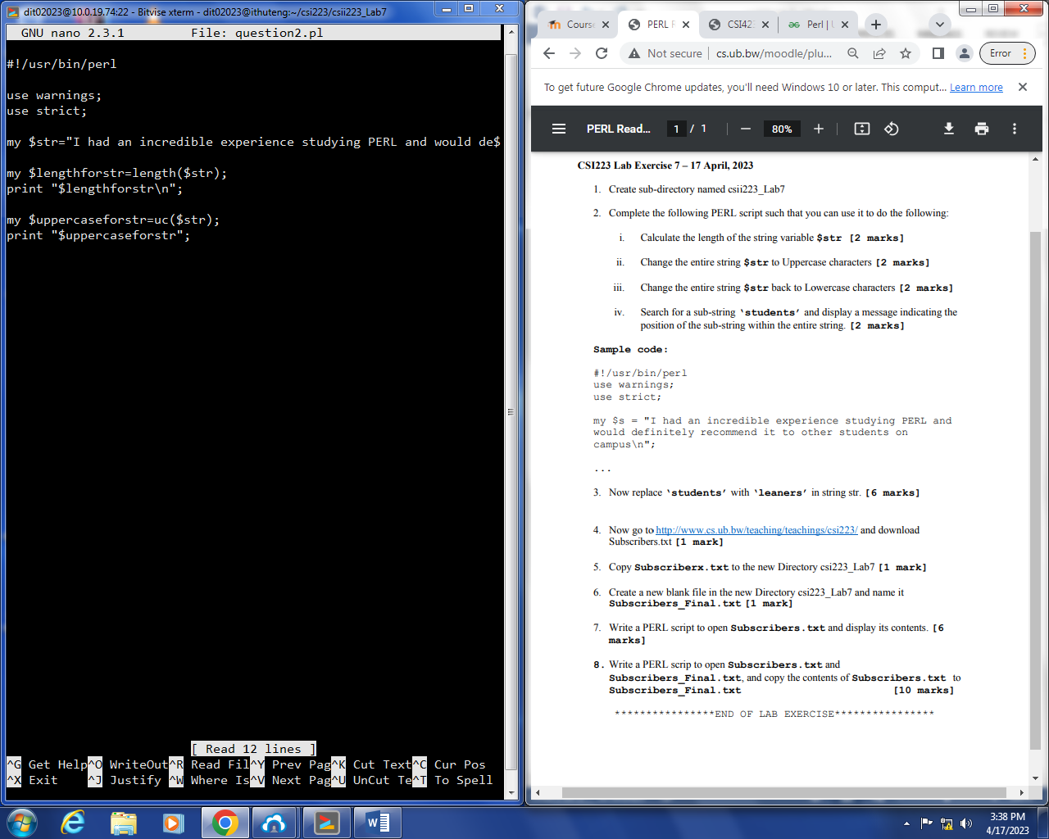
ii. uppercase of str-I used uc() function to convert to upeercase
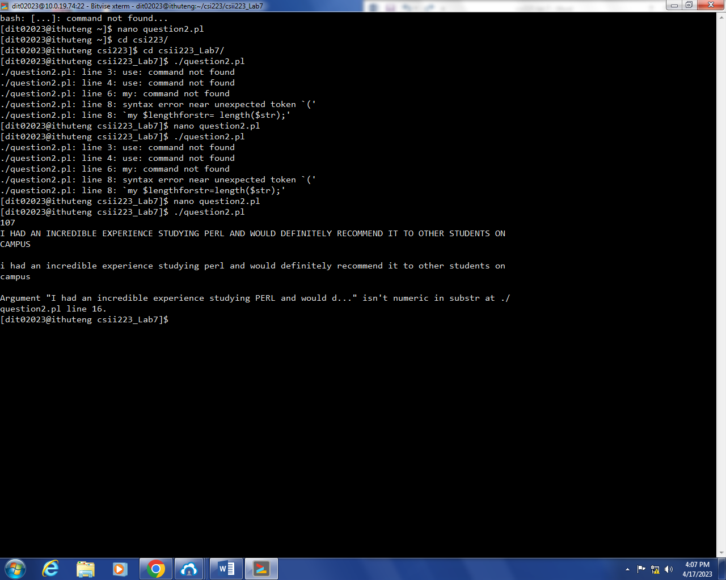
iii.lowercase of str-I used lc() function to convert to lowercase
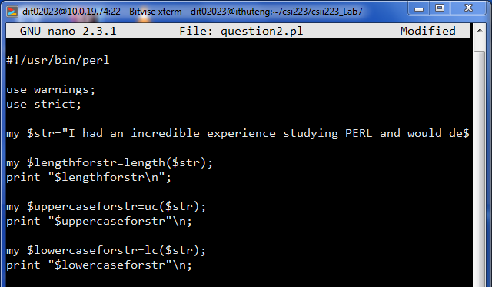

iv. substring ‘students’ from str-I used index() function.
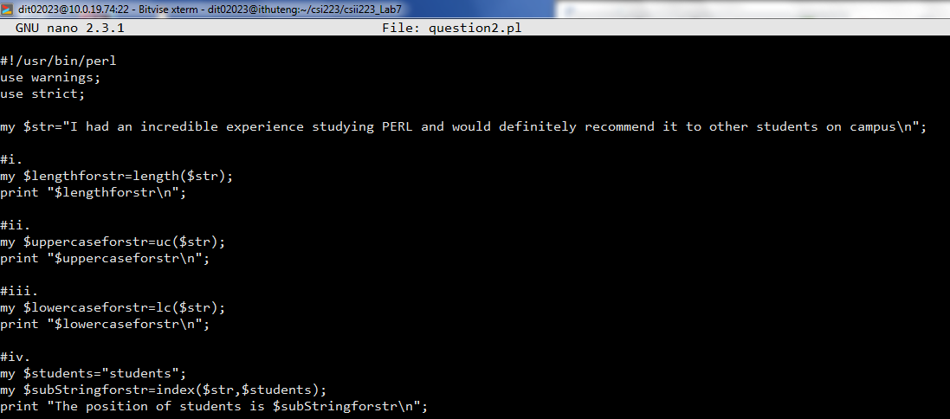
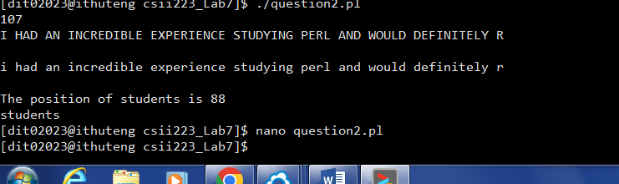

- Replacing ‘students’ with learners
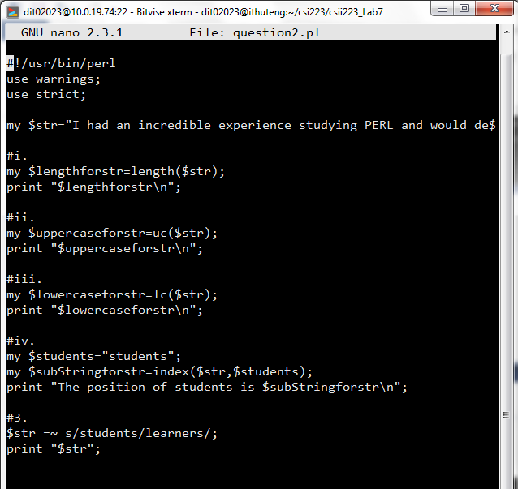
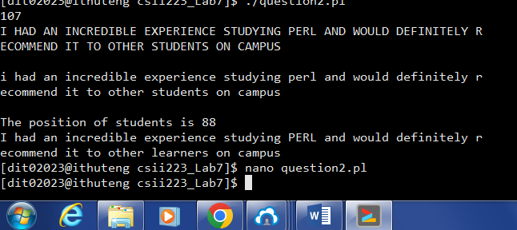

- Downloading subscribers.txt
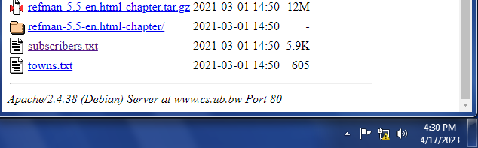

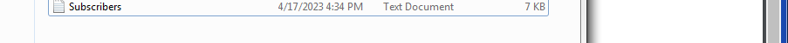

- Copying the file to the directory
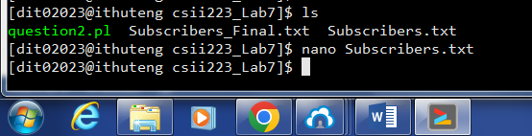

- Creating Subscribers_Final.txt

- Opening Subscribers.txt and displaying its contents
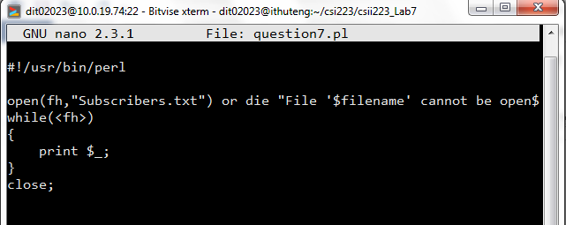
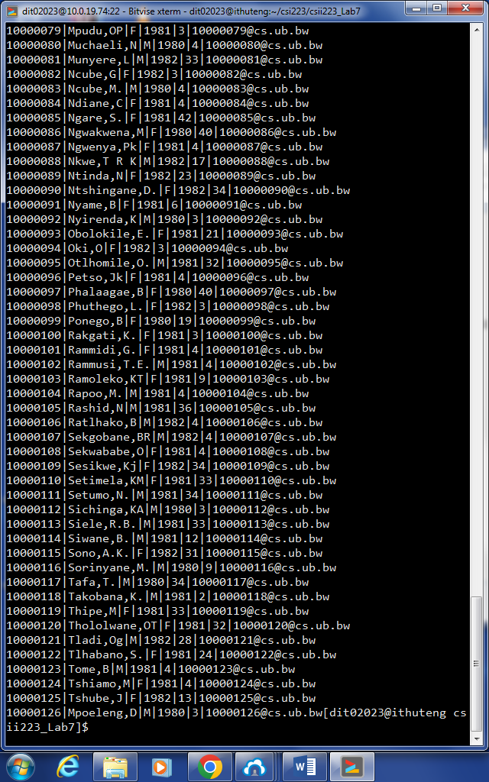

- Copying the subscribers.txt content to Subscribers_Final.txt


